**Observation, Notetaking, & Sketching Field Notebook Assignment: BIRD ID & BEHAVIOR**

By Dr. Jennifer Purrenhage, University of New Hampshire

*This is an original field notebook assignment by J. Purrenhage, but I’d like to acknowledge influences from Bethann Garramon Merkle, MFA (*[*https://www.commnatural.com/*](https://www.commnatural.com/)*) and John Muir Laws (*[*https://johnmuirlaws.com/*](https://johnmuirlaws.com/)*).*

* *Page 1*: Assignment Overview
* *Page 2*: Assignment Handout for Students
* *Short article/resource*, *re*: Using spectrograms to read bird songs and calls: [*https://www.audubon.org/news/start-using-spectrograms-read-bird-songs-and-calls*](https://www.audubon.org/news/start-using-spectrograms-read-bird-songs-and-calls)

**Note to instructors:**

**This Field Notebook Assignment was created for NR 740: Inventory and Monitoring of Ecological Communities at the University of New Hampshire.**

* *Prior knowledge/pre-requisites*: At UNH, NR 740 is required for Wildlife & Conservation Biology (WCB) students in their Senior year. **Students come to NR 740 with a strong foundation in ecology and varied experiences/familiarity with different taxonomic groups, so not all students have direct experience with birds** (WCB students choose from a list of animal ecology/morphology/evolution electives, including Herpetology, Ornithology, Mammalogy, Ichthyology, and Vertebrate Morphology). Some students have taken a behavior course prior to taking NR 740, but some have not. **While no sketching experience is necessary, we do try to lay the groundwork in NR 740:** Early in the semester, my NR 740 students participate in a 50-minute *Sketching for Scientists* ‘workshop’—a series of sketching exercises (led virtually by Bethann Garramon Merkle, MFA) to provide practice with a few very basic techniques (e.g., contour drawing, layout, texturing, lettering) intended to free them of some of their sketching anxiety/hesitation. Early on, and throughout the course, I make a point of reminding students that this is not an art class. We are using annotated sketching to enhance (and make more efficient) our notetaking in the field. I believe, and remind them often, that it is often the self-described non-artists who make the best (most useful) field sketches because they tend to focus on and exaggerate the field marks—*like caricatures*—in their sketches, and they use annotations well.
* A big part of NR 740 is learning and practicing techniques for wildlife research with an emphasis on field techniques. We use field notebooks to document field methods (‘field lab’ entries) and to develop a personal and professional practice of notetaking and documentation during field work (independent ‘sit spot’ entries). In NR 740, we often use independent Sit Spot Assignments (like the one shared here) to provide additional practice in techniques learned in class/lab. I have used this Birds & Behavior assignment both before and after our Bird Inventory & Monitoring labs (in different years). In class/lab, students practice ways to learn bird ID for a limited list of local birds using a suite of ‘clues’ for identification (e.g., field marks, sound quality, habitat, behavior). This field assignment worked well as both a ‘pre-lab’ and a follow-up/practice activity.
* If bird ID and behavior doesn’t fit into your course objectives, this assignment can be modified for different taxonomic groups and/or to focus solely on the behavioral observation aspect of the prompt.

**The general field notebook expectations for NR 740 are not included in the student handout** (*next page*) **because at this point in the semester students are familiar with the expectations, which are also articulated in the course syllabus.** Students in NR 740 have the freedom to experiment with different layouts/styles for their field notebook entries, but they are reminded to write for themselves *and* for posterity. Every page of a given entry must include the date (at the top of each page) AND every entry must include standard metadata:

* Date: day, month, and year (*e.g.,* 30 Aug 2023); every page of your notebook must be ‘dated’
* Location: Be specific enough for others to find the location in 10 years (imagine they are unfamiliar with the area): *GPS coordinates; Address or at least Town, State; Consider drawing or including a basic map/sketch of the area.*
* Time stamps: You must include *start* & *stop* times (*it’s also good to include periodic time stamps*)
* Weather/Field Conditions: Use a weather app to record at least *air temp., wind speed & direction.* Also describe *general conditions* (sun; part sun; part cloudy; overcast; raining; snowing).
* Personnel: Your name (or initials) and the names of everyone else you are in the field with – it is not enough to say “with NR 740 class” unless you include a complete roster in the end pages of your notebook. Include the names of any guests, as well as your instructor and TA’s names, when applicable.

Choose a place (a ‘sit spot’) away from too much human traffic, where you can sit quietly and make observations for this Sit Spot Observation & Field Note.

*The ‘sit spot’ entry in your field notebook must include metadata detailed observations, annotated sketches, and your reflection and responses to the specific prompts provided. Take a moment before heading into the field to review the general expectations for your field notebook, including requisite metadata and formatting.*

**Focus on:** Practice Bird Identification by Sound, Sight, Context (habitat, location), & Behavior.

Explore Visualizing (and making visual representations of) Bird Vocalizations.

Observe the behavior of 1 bird (or group of birds) & document via annotated sketching.

**Once you reach your spot, get settled & sit quietly for ≥ 10 minutes without writing or moving much.** 

Let the world adjust to your presence. Observe. Note your starting time.

**After your initial 10+ minutes of stillness, begin to write and sketch.**

1. **Note the general (*default*) 'Field Notes' guidelines for your Sit Spot Observations (below).**

* Record metadata. (*Per syllabus*: Date, Location, Time stamps, Weather, Personnel)
* Maintain a daily species list. Today’s focus is birds but record any and all species you observe.
* Take descriptive notes to document what you observe *today.*

1. **For today’s focus on Bird ID/description,** pay close attention to (and take notes about) the following details to help you deepen your observation skills and identify the species you observe:

* the **quality of sounds** you hear (*e.g.*, tone, pitch, mnemonics)
* **distinguishing field marks** (*e.g.*, eye rings, eye lines, wing bands, rump patches)
* **description of the habitat**:What kind of habitat are you in? Is there water nearby? Are you on a field edge? a road edge? in the woods? in a concrete jungle? What ambient noise do you hear?
* **the bird’s use of habitat / microhabitat**
* **the bird’s behavior** (*e.g*., hopping, hovering, tail-flicking, flight patterns, feeding, interacting)

1. **Use ≥ 2 accompanying sketch(es) to enhance your notes about the bird(s) you observe.**

Do *at least* 2 of the following (*push yourself to do > 2*) *and* **annotate your sketches**:

* Sketch the bird, including key ‘field marks’ (*as seen in the Pine Warbler sketch: below, left*).
* Sketch what the bird’s song or call sounds like. Ascending? Descending? Staccato? Something else? It can be helpful to visualize the spectrogram of a call *(as below, right)*.
* Sketch the location of the bird in the context of its associated habitat features/structures.
* Create a series of rough sketches of one bird over time to demonstrate behavior (*include time stamps*).

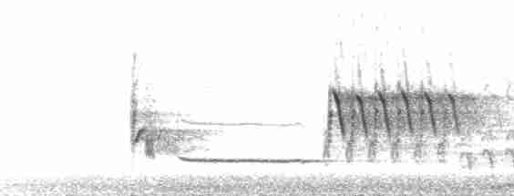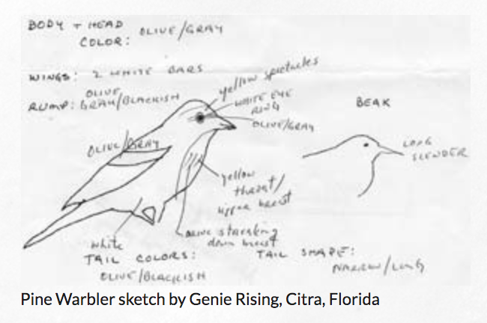

*from Project FeederWatch,*[*https://feederwatch.org/learn/identifying-birds/*](https://feederwatch.org/learn/identifying-birds/)



**Eastern Towhee**

Ryan Sanderson

You will describe *at least* 1 bird in detail for this entry. *Keep in mind*: There is always something   
new to note, even about the most familiar species. Through deep observation we can see individual variation. **Describe the bird in front of you**, not some ‘textbook’ idea of what that species is like.