Field Notebook Assignment: TURTLE MONITORING FIELD LAB ENTRY

By Dr. Jennifer Purrenhage, University of New Hampshire

This is an original field notebook assignment by J. Purrenhage, but I’d like to acknowledge influences from Bethann Garramon Merkle, MFA (https://www.commnatural.com/) and John Muir Laws (https://johnmuirlaws.com/).

- Page 1: Assignment Overview
- Pages 2-3: Lab/Assignment Handout for Students

Note to instructors:

This Field Notebook Assignment was created to accompany the Turtle Lab in NR 740: Inventory and Monitoring of Ecological Communities at the University of New Hampshire. The Turtle Lab itself uses the research protocol from EREN’s Turtle Pop 2.0 Project: https://erenweb.org/active-projects/turtlepop-2-0/.

- At UNH, NR 740 is required for Wildlife & Conservation Biology (WCB) students in their Senior year. Students come to NR 740 with a strong foundation in ecology and varied experiences/familiarity with different taxonomic groups (WCB students choose from a list of animal ecology/morphology/evolution electives, including Herpetology, Ornithology, Mammalogy, Ichthyology, and Vertebrate Morphology). Students are not expected to have prior experience with turtles before this lab. In fact, this lab (and the field notebook assignment) could easily be used with an introductory ecology/biology course.

- This field notebook assignment requires some sketching; however, students are not expected to have prior sketching experience before this lab. Early in the semester, my NR 740 students do participate in a 50-minute Sketching for Scientists ‘workshop’—a series of sketching exercises (led virtually by Bethann Garramon Merkle, MFA) to provide practice with a few very basic techniques (e.g., contour drawing, layout, texturing, lettering) intended to free them of some of their sketching anxiety/hesitation. This lab is typically our first lab of the semester and takes place before our Sketching for Scientists workshop.
- A big part of NR 740 is learning and practicing techniques for wildlife research with an emphasis on field techniques. We use field notebooks to document field methods (‘field lab’ entries) and to develop a personal and professional practice of notetaking and documentation during field work (independent ‘sit spot’ entries). Students in NR 740 are required to create a field notebook entry for every field lab in the course. They are expected to follow a general set of field notebook expectations (see below), but students are also given a lab handout with a field notebook assignment specific to each field lab (like the Turtle lab field notebook assignment shared here).

The general field notebook expectations for NR 740 are not included in full in the student handout (on the following pages) because those expectations are articulated in the course syllabus, but you’ll see reminders of metadata and some of the other field-notebook expectations included in the handout as this is typically our first lab activity in NR 740. Students in NR 740 have the freedom to experiment with different layouts/styles for their field notebook entries, but they are reminded to write for themselves and for posterity. Every page of a given entry must include the date (at the top of each page) AND every entry must include standard metadata:

- Date: day, month, and year (e.g., 30 Aug 2023); every page of your notebook must be ‘dated’
- Location: Be specific enough for others to find the location in 10 years (imagine they are unfamiliar with the area): GPS coordinates; Address or at least Town, State; Consider drawing or including a basic map/sketch of the area.
- Time stamps: You must include start & stop times (it’s also good to include periodic time stamps)
- Weather/Field Conditions: Use a weather app to record at least air temp., wind speed & direction. Also describe general conditions (sun; part sun; part cloudy; overcast; raining; snowing).
- Personnel: Your name (or initials) and the names of everyone else you are in the field with – it is not enough to say “with NR 740 class” unless you include a complete roster in the end pages of your notebook. Include the names of any guests, as well as your instructor and TA’s names, when applicable.

Wetland Herps Inventory & Monitoring: TURTLE LAB
(with a side of Pond-breeding Amphibians)

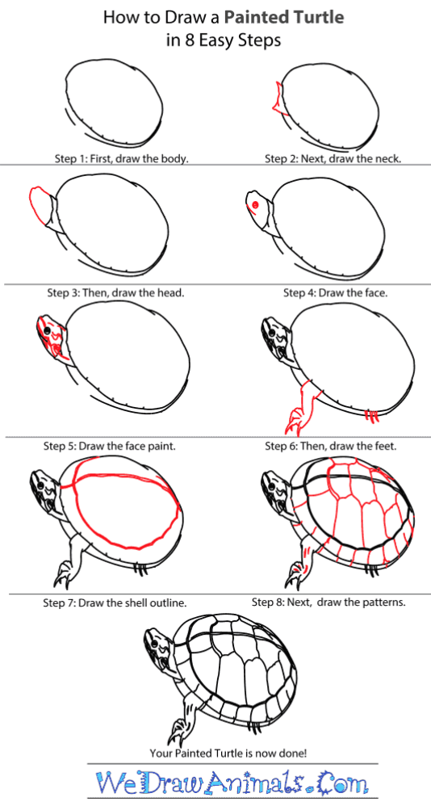
In this field-based lab, we will:
- begin to establish good field notetaking habits
through the creation of field notebook entry #1
- learn and practice a common technique for
inventory and monitoring of freshwater turtles:
funnel trapping (using hoop & minnow traps)
- learn to identify multiple species of freshwater
turtles native to NH (2-3 species, I hope!)
- learn how to sex turtles (male v. female)
- review turtle anatomy (recall the pre-lab)
- practice collecting common morphological data for studying turtle populations
- learn how to mark turtles for capture-mark-recapture studies (& practice the shell/scute-notching method)
- learn about ongoing freshwater turtle research
happening here in southern New Hampshire
- time permitting, we may discuss methods used
for inventory and monitoring of pond-breeding
amphibians (frogs and salamanders)

We plan to check traps at 2 ponds during lab:

- A section of the Durham Reservoir at the UNH Observatory (Spinney Lane, Durham, NH). We call this site ‘UNH Observatory.’
- A beaver pond in the Lubberland Preserve (Dame Road, Newmarket, NH). We call this site ‘Lubberland-Dame.’

In advance of lab, you should have:

- Reviewed the requirements (detailed in the syllabus) for recording ‘metadata’ and field observations in your field notebook. I’ve included reminders below for your reference.
- Downloaded reliable apps to your phone for recording GPS coordinates and weather data.
You can use these same apps throughout the semester for consistency in your field notebook.
- Reviewed your responses to the Turtle Inventory & Monitoring pre-lab assignment. Any terms/definitions that might be helpful to reference during lab should be added to a ‘glossary’ in your field notebook (e.g., carapace, plastron, cloaca, scute) before coming to lab.

Recall that one of our objectives for this lab is to begin to establish good field notetaking habits through the creation of your field notebook entry. Field notebook tips/reminders and a checklist for your Turtle Lab field notebook entry are detailed on the next page.

Field Notebook expectations are outlined in our course syllabus. Use the general tips/reminders and the checklist (specific to this lab) below to practice good field observation and notetaking in your Turtle Lab field notebook entry.

Practice attention to detail. The first step of good field notetaking is deep observation, a critical skill for biologists. For your notes to reflect attention to detail, you must begin by being a detail-oriented observer. I will repeat it again and again this semester, but I cannot express enough how valuable this skill is. If you can demonstrate your observation and record-keeping skills, you will be sought-after in this field.

Use proper terminology in your notes.
(Recall the pre-lab.)

Remember to sketch, doodle, or draw diagrams.
It may be trite, but a ‘picture’ really can be worth 1,000 words. And an annotated sketch may be worth 10,000 words!

CHECKLIST for your Wetland Herps (Turtle Lab) Field Notebook entry:

- Metadata.

Date (day – month – year)
Name of Primary Observer (you)
List all other personnel in the field
Location Description:
- Address (if possible)
- City, State
GPS Coordinates
Start/Arrival Time
Stop/Departure Time
Weather | Describe general conditions: sunny/clear; partly sunny; overcast; drizzle; hard rain; snow; other
Air Temperature
Wind Speed & Direction

- Take descriptive notes about the pond/site and its surroundings, about the turtles, other animals, the vegetation, and anything else you observe.
- Keep a species list (turtles, plants, tadpoles, fish, caterpillars, birds calling, vultures soaring …).
- Respond in writing (in your notebook) to any Journaling or Sketching Prompts announced in lab.

Imagine you’re about to start as a field tech on the turtle project. You need good notes so you know what to do when you’re alone in the field next week! Even better, imagine someone else needs your notes:

- Take good notes on protocol (methods) for turtle trapping, ID, sexing, marking, and measurements.
- Include a sketch(es) to accompany your notes: SHOW us “How to sex a painted turtle.” (required)
- Feel free to include any additional sketches to enhance your notes. (optional)

