Instructions to download projects WildlifeBlitzGarneau or RoadkillGarneau from EpiCollect app

Website for reference:
http://www.epicollect.net/instructions/
Project website:
http://epicollectserver.appspot.com/project.html?name=RoadkillGarneau or remove RoadkillGarneau and insert WildlifeBlitzGarneau after name= in the URL above

DROID CONCERNS: there is no way to enable the project form (RoadkillGarneau OR WildlifeBlitzGarneau to update, that is to say I might add some more questions to grow the scope and your form would not readily update). iPhone’s do this with a toggle button in settings, but the creator told me that Droids just cannot do this right now. A work around to avoid this issue is to reload the project (RoadkillGarneau or WildlifeBlitzGarneau) on the Android using the menu and 'load project'
Droid Instructions (adapted from Epicollect.net instructions):
- Download epicollect app off the Google play store or scan this QR code.

- Once installed, to load a new project click the MENU button on the phone.
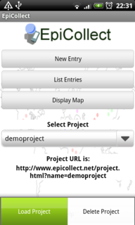
- Click to load project and type in either RoadkillGarneau or WildlifeBlitzGarneau to upload the project form.
- Project forms you select will be stored in the Select Project download list if you want to work between them.
- You are now ready to start adding entries:
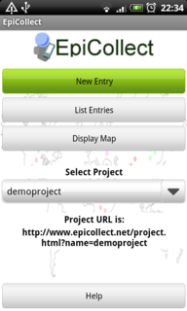

- Select NEW ENTRY to add a wildlife or roadkill entry (be sure you are loaded w/ the right form).
- Allow location to be used (to get associated lat/long) by tapping the window asking for GPS location (make sure you GPS enabling is set on your phone).
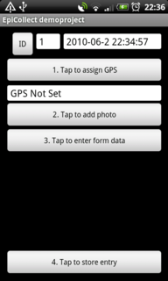

- Click in area where photo is mentioned to start your camera and take a picture of the live or dead species and CONFIRM to keep the photo.
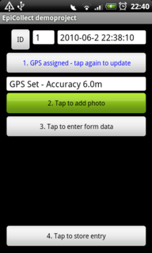

- Commence entering form data as best you can by tapping to enter form data. You can always return to the same entry to make adjustments at a later date (until you sync it to the Epicollect main site). For example, if you note roadkill and want to respond to the question that asks for duration of time it remained on the road, you might decide to enter what you can now and then return to that once the roadkill is removed from the road.
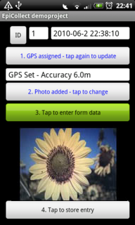
- When done CONFIRM entry is complete. Next tap to STORE the new entry.
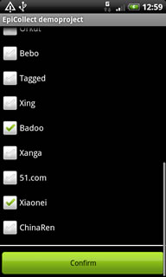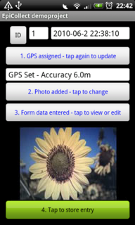

- Again, you can return to the entry and adjust as long as you have not synched it yet. Once synching occurs, you no longer can update that entry.
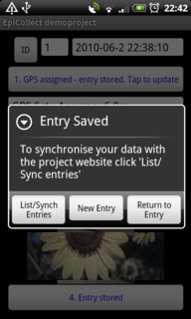
- To alter an entry, instead of selecting NEW ENTRY now click LIST ENTRIES and select the one you want to update. Make adjustments and resave it.
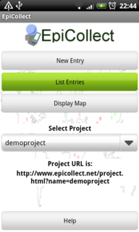

- When entry is ready for upload to the Epicollect server, then hit the Tap to Synchronize button and await upload. NOTE: you must either have 3G/4G or wireless signal to sync your data.
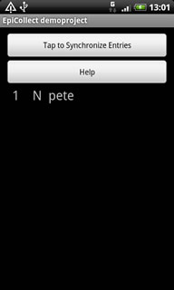
When synchronization is complete the N before the name of the entry will turn to Y and the top button will read No Entries to Synchronize.
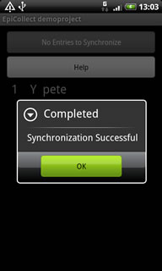

For data analysis:
To view on the map, select the DISPLAY MAP option. Your location will show up as the blue dot and the compass button if clicked lets you select if you want to view in Map/Satellite.
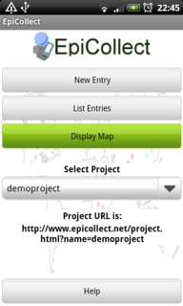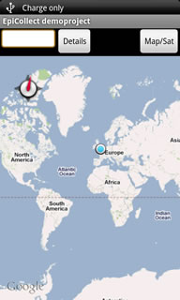
Click the menu button and decide if you want to view Local (your entries) or Remote (everyone who participated in the project’s entries)

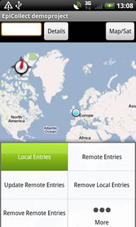
Tap a point and you can see the data entered by hitting the Details button:
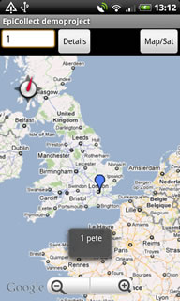
For Remote entries:
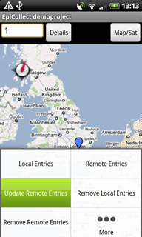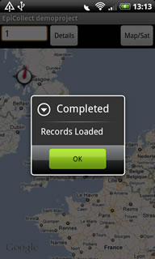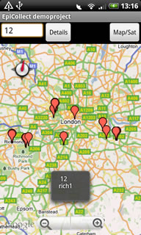
Local entries are shown in BLUE and Remote entries are in RED.
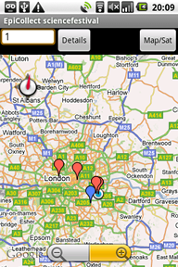
You can do some simple queries on the phone too by hitting the Menu button then selecting FILTER:
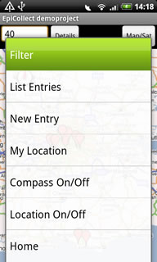
This will allow you to filter anything that is in the data format that will allow queries. Not all my questions will allow this. One potential might be to select for ONLY Raccoons. Here is one visual from the website for demonstration:
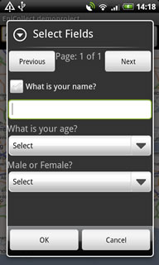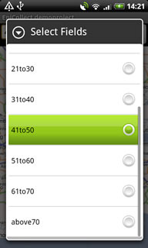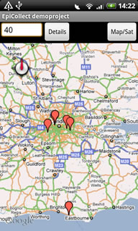

For more sophisticated mapping/graphing do to the project’s main page online.
The project main page will be a modification of this URL:
http://www.epicollect.net/project.html?name=demoproject where you remove demoproject and type the appropriate project name (RoadkillGarneau or WildlifeBlitzGarneau)

The map view is below and any question in my form that I asked to graph is showing up on the right hand window

Time slider will allow you to select newer or older entries
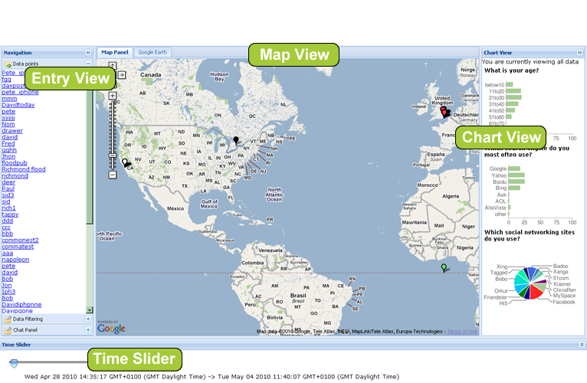
Clicking on one entry gives the detailed information associated with that session. All entries are listed on the left side of the screen and can be clicked on readily:
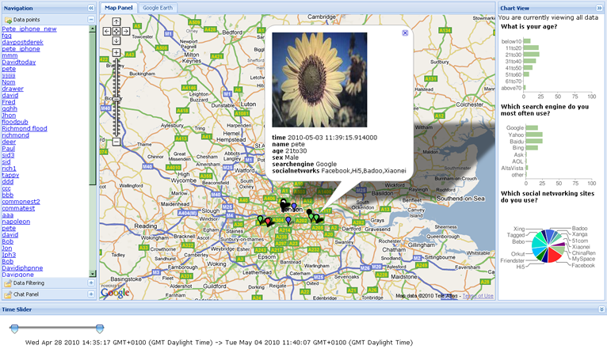
You can do data filtering here by clicking in the lower left for the filter tool:
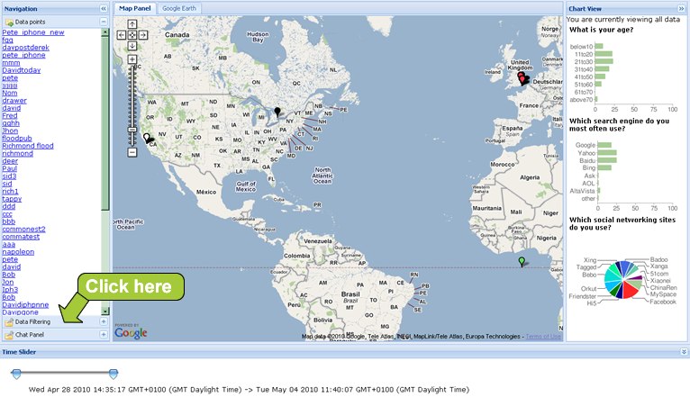
This is an example of a filter and is not available for all types of questions that were asked on the form, only a subset.
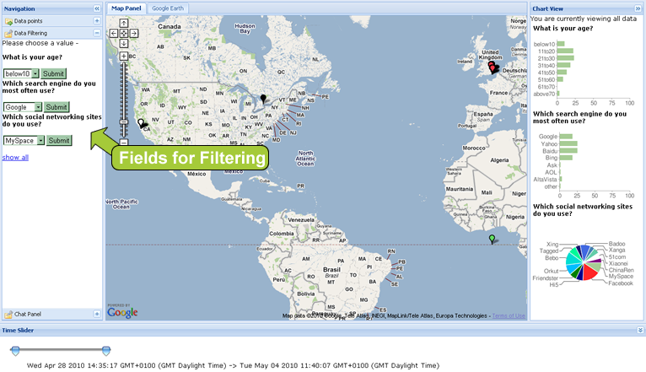
Your maps and your charts will update as you make these filters.
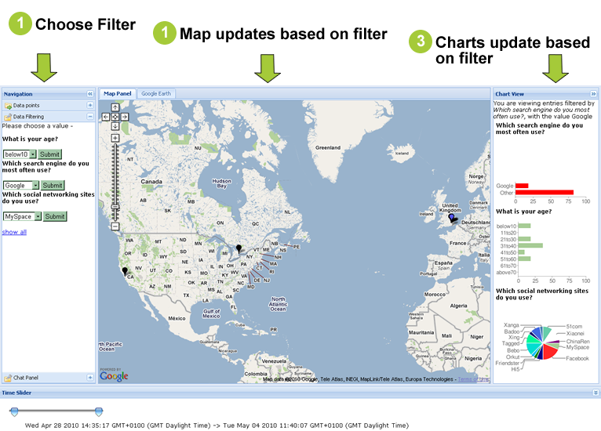
You can even GOOGLE TALK with someone across the country/globe that is entering data if they have a google account and are available.
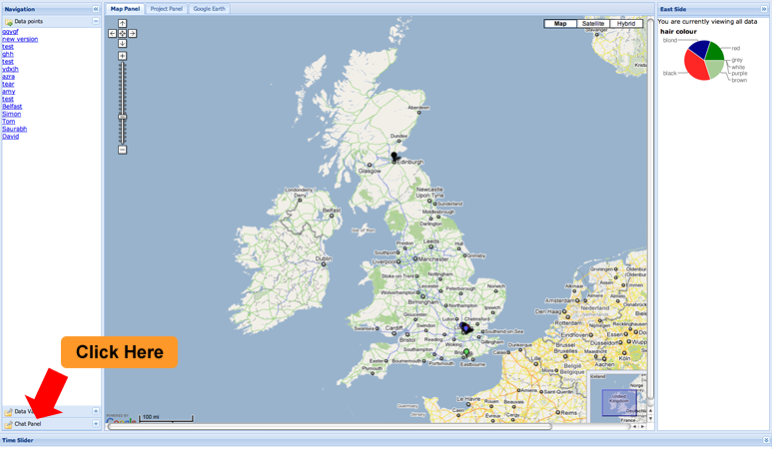
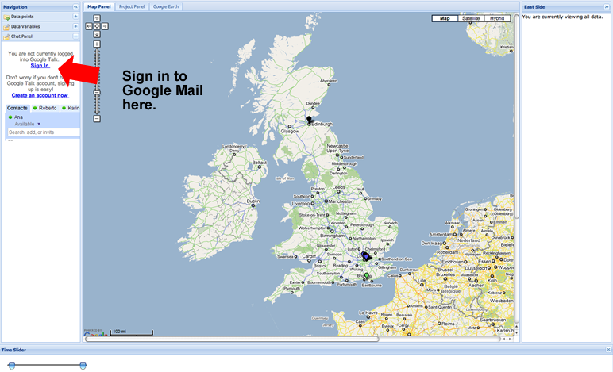
You will see your list of contacts and you can commence a Google Talk Session if you have permission.
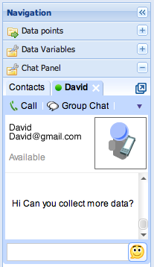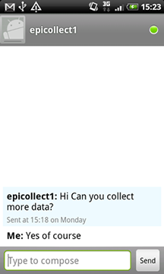
We can also be really FANCY and view the map in Google Earth if you have it installed. The data can be saved as a .KML file.
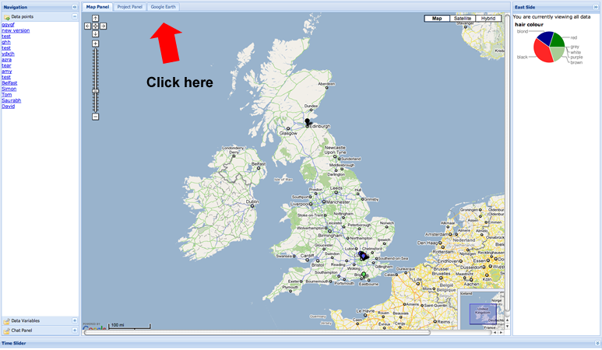
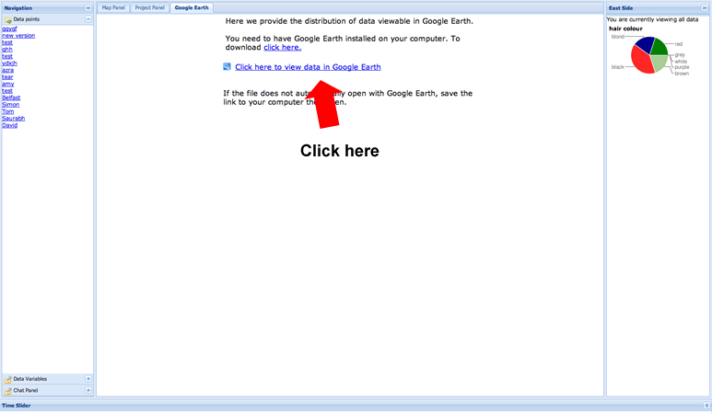
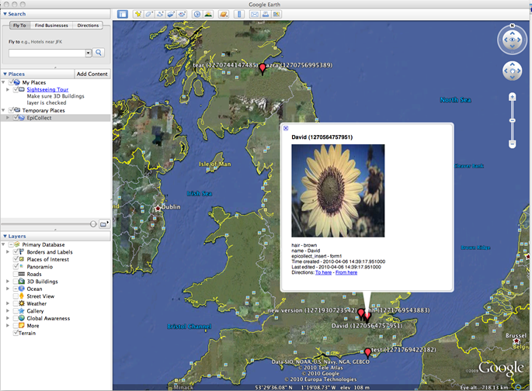
Unfortunately you cannot chart or filter in Google Earth.

