Instructions to download projects WildlifeBlitzGarneau or RoadkillGarneau from EpiCollect app

Website for reference:
http://www.epicollect.net/instructions/
Project website:
http://epicollectserver.appspot.com/project.html?name=RoadkillGarneau or remove RoadkillGarneau and insert WildlifeBlitzGarneau after name= in the URL above
iPhone (adapted from Epicollect.net instructions):
- Download epicollect app off the apple app store
- Load epicollect and go to the SETTINGS option and toggle ON to UPDATE FORMS
- Change user email to your email address
- Go to the project window and click, this opens a new series of windows and you select NEW
- Type in the form of interest (WildlifeBlitzGarneau or Roadkill Garneau) and upload the form
- In upper left hit the back EPICOLLECT ARROW to return to epicollect main window
- Select NEW ENTRY to add a wildlife or roadkill entry
- Allow location to be used (to get associated lat/long)
- Click in area where photo is mentioned to start your camera and take a picture of the live or dead species
- Commence entering form data as best you can. You can always return to the same entry to make adjustments at a later date (until you sync it to the Epicollect main site). For example, if you note roadkill and want to respond to the question that asks for duration of time it remained on the road, you might decide to enter what you can now and then return to that once the roadkill is removed from the road
- Hit SAVE to save the entry. Again, you can return to the entry and adjust as long as you have not synched it yet. Once synching occurs, you no longer can update that entry.
- To alter an entry, instead of selecting NEW ENTRY now click LIST ENTRIES and select the one you want to update. Make adjustments and resave it.
- When entry is ready for upload to the Epicollect server, then hit the SYNC button in the upper right of that entry form and await upload. There will no longer be a message below the entry stating it is not yet uploaded. NOTE: you must either have 3G/4G or wireless signal to sync your data.
For data analysis:
To view on the map (either LOCAL which are your entries, or EXTERNAL which is everyone else who is adding to the project OR ALL which is everyone), select the DISPLAY MAP option.
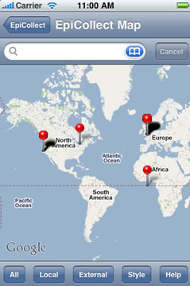

You can do some simple queries on the phone too by typing in the search window above:
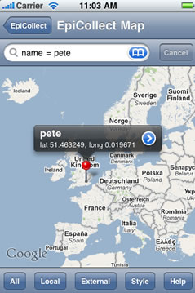

For more sophisticated mapping/graphing do to the project’s main page online.
The project main page will be a modification of this URL:
http://www.epicollect.net/project.html?name=demoproject where you remove demoproject and type the appropriate project name (RoadkillGarneau or WildlifeBlitzGarneau)

The map view is below and any question in my form that I asked to graph is showing up on the right hand window

Time slider will allow you to select newer or older entries
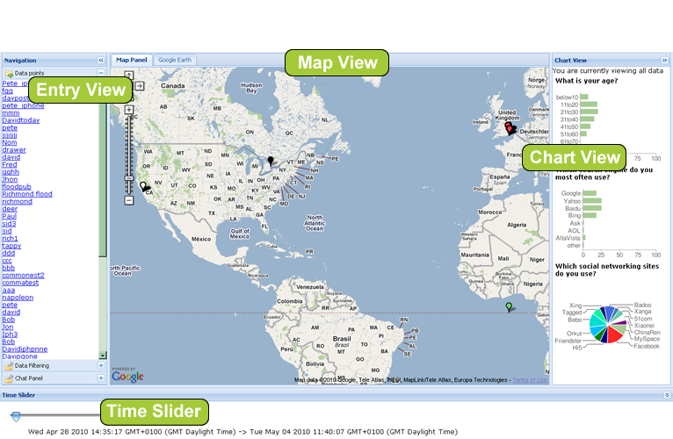
Clicking on one entry gives the detailed information associated with that session. All entries are listed on the left side of the screen and can be clicked on readily:
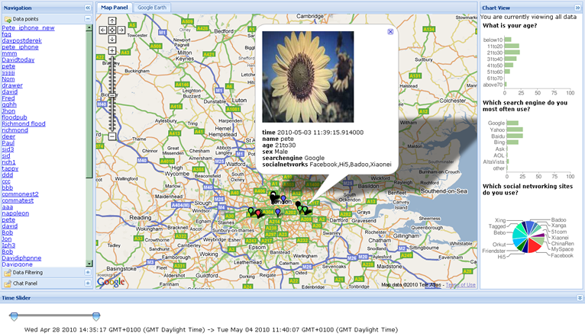
You can do data filtering here by clicking in the lower left for the filter tool:
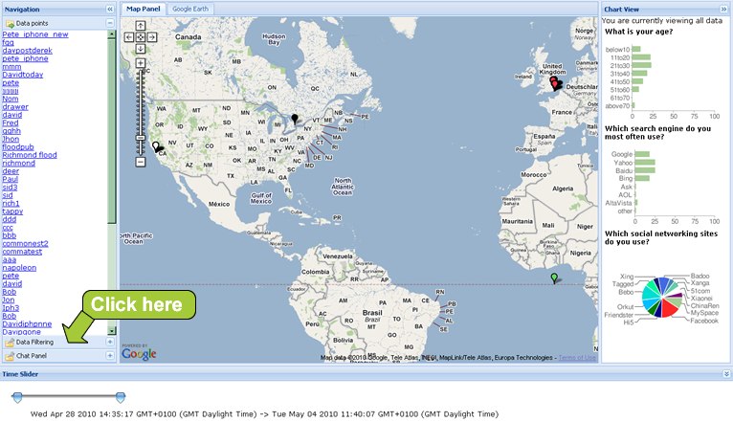
This is an example of a filter and is not available for all types of questions that were asked on the form, only a subset.
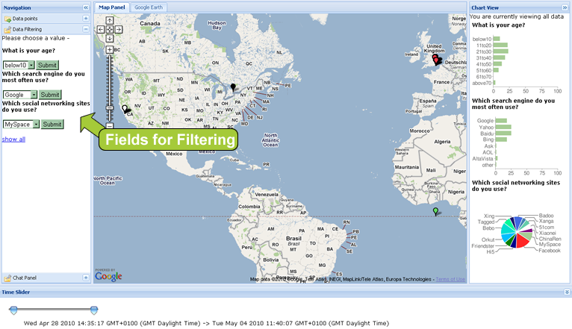
Your maps and your charts will update as you make these filters.
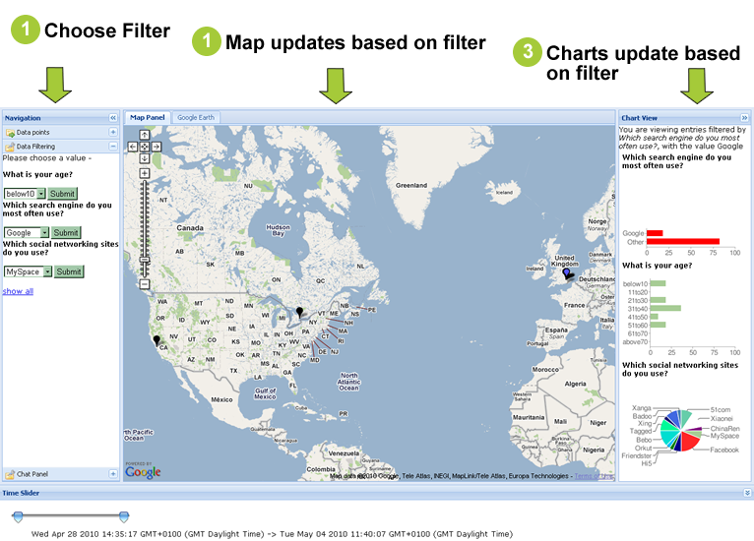
You can even GOOGLE TALK with someone across the country/globe that is entering data if they have a google account and are available.
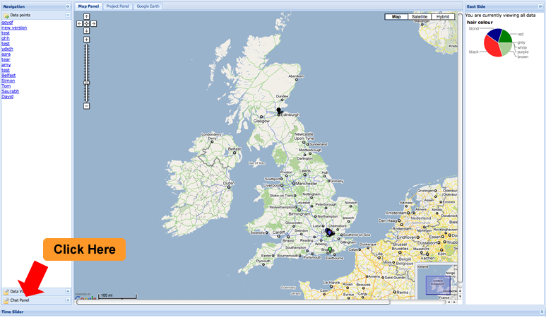
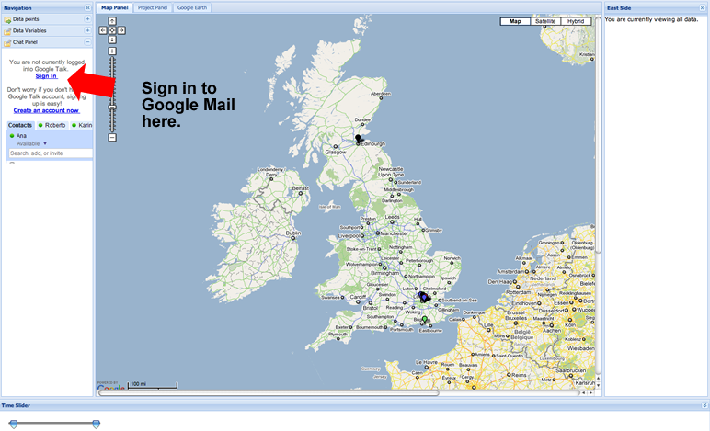
You will see your list of contacts and you can commence a Google Talk Session if you have permission.
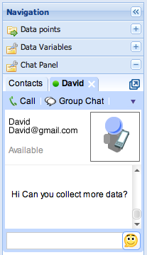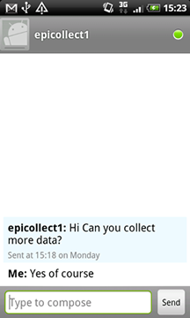
We can also be really FANCY and view the map in Google Earth if you have it installed. The data can be saved as a .KML file.
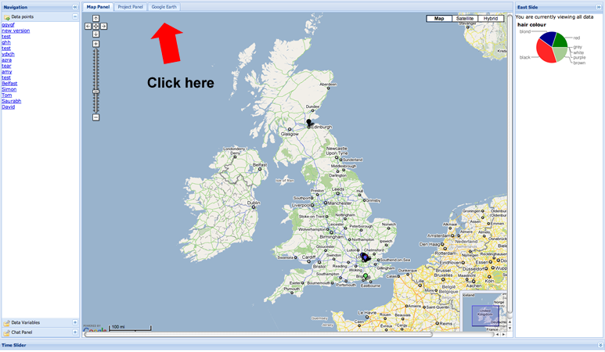
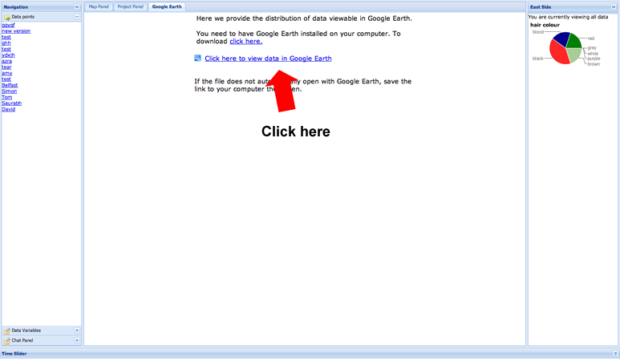
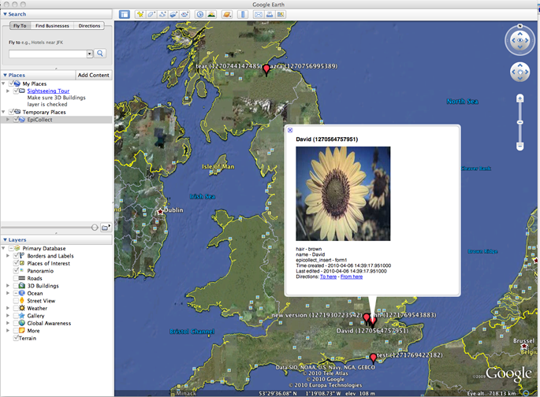
Unfortunately you cannot chart or filter in Google Earth.

