Using a multi-site, student-collected data to explore forest species composition and dynamics: a computer lab exercise.

Rachel Collins (Roanoke College rcollins@roanoke.edu), Jerald Dosch (Macalester College), Kristy Hopfensperger (Northern Kentucky University), Karen Kuers (University of the South: Sewanee), Erin Lindquist (Meredith College), Charles McClaugherty (University of Mount Union), Tim Menzel (Piedmont College), and Fernando Nieto (SUNY Old Westbury).

***Presented at REEFS: Resources for Ecology Education, Fair and Share at ESA Annual Meeting in Fort Lauderdale, FL August 2016.***

# Forest Species Composition:

# *Seeing the forest for the trees*

**Intended Learning Outcomes**

On completion of this laboratory exercise students will be able to

* Represent tree community data in graphic form
* Analyze species composition across multiple forests
* Articulate community composition dynamics

**Schedule**

1-hour: Developing Research Questions

3-hours: Data Analysis

**Introduction**

In this lab, students will learn foundational concepts of forest community dynamics and apply quantitative skills to data analysis and interpretation activities. Students will use species data collected from four different forests in three states. The data were generated from a shared method protocol (Kuers et al. 2014) and database of the Permanent Forest Plot Project (PFPP) of the Ecological Research as Education Network (EREN; www.erenweb.org). Here, students will analyze and interpret data to articulate forest species composition dynamics. This lab is designed to train students in *real-world* skills and experiences of a collaborative ecologist.

**Background**

**I. A Few Key Concepts in Forest Ecology**

**Species Composition**

***Species composition*** is the identities and abundances of all the species in a community or area. A ***community*** is a group of organisms of different species living and influencing each other in one area. Interactions between members of a community can change its species composition over time (Connell and Slatyer 1977). Because species hold different ecological roles, knowing the identity of species is as important as knowing how many different species are in an area. We often depict species composition in graphical form, so that we can assess species composition in an area and compare species compositions among areas. In the example species composition figures below, you can see that each site has the same species, but in different abundances (Fig. 1). The top figure depicts an oak-hickory forest (i.e., oaks and hickories are the most abundant of all of the canopy trees). The bottom figure represents a beech-sugar maple forest. Knowing what the most abundant canopy trees are gives us information about what other species may be in the forest, soil quality and moisture, and successional stage.

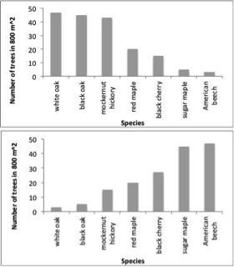

**Figure 1. Example species composition figures.**

**Foundation species**

Species hold different roles in communities and some species contribute more to the ecosystem functioning of a community than other species do. Species that have strong influences on communities are called ***foundational species*** and can operate in different ways (Ellison et al. 2005). Here are some examples.

● ***Dominant species*** are very good competitors and can competitively exclude other species (Grime 1984). Because dominant species are good competitors, they tend to be very abundant. Being abundant means that they may influence the dynamics of a community more than if they were less abundant (Clements et al. 1929). Dominant species are often the most numerous species in a particular canopy layer.

● ***Structural species*** best fit the role of trees in the forest. These species create the structure of the ecosystem just as coral creates the coral reefs. Trees not only provide the structure of forests, but also play a dominant role in controlling nutrient flow, creating habitat, and affecting the physical environment (a forest floor has less sunlight and less wind than an open field) (Huston 1994).

**Forest Vertical Structure**

Forests are made up of *vertical layers* and are created by the trees and other plants that grow to different heights. Trees can have different ecological roles depending on which layer they are in. The tallest trees in the forest are dominant trees. These trees have crowns that emerge above the main canopy of the forest. Codominant trees have crowns that make up the main portion of the canopy. Together dominant and codominant trees make up the overstory of a forest and tend to have the largest trunk diameters. The midstory of a forest is made up of intermediate trees whose crowns enter into the main canopy, but do not reach the top of the main canopy. Overtopped trees are also part of the midstory and are taller than 1.37 m tall (the height at which we measure tree diameter: DBH), but shorter than the main canopy. The understory of a forest are all plants shorter than 1.37 m tall, and is usually the most diverse forest layer because it contains tree seedlings, shrubs, and herbaceous species. See the different terms used in each forest vertical layer in Figure 2.

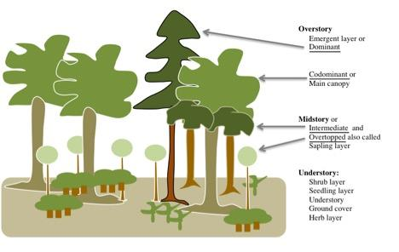

**Figure 2. Diagram of vertical forest structure and terms.**

We can use tree diameter as a surrogate for which vertical layer a tree is in. Overstory trees (dominant and codominant) tend to have the largest diameter, Intermediate trees have smaller diameters, and overtopped trees have the smallest diameters as is evident from the forest plots in Bennett Springs and Timberview (Figure 3).

Each species fills a different niche, which can help in assessing forest dynamics. Most trees are not reproductive until they reach codominant or dominant crown class (i.e., overstory). Tree species adapted to the midstory may never grow taller than the intermediate crown class. When assessing the midstory of a forest it is important to know which individuals are “just passing through” on their way to the canopy and which ones are fully mature. In the Species List at the end of the lab exercise, species that reproduce in the midstory and canopy are noted (Appendix 1).

A wide variety of factors control forest structure. Physical characteristics such as topography, soil type, and aspect can determine the type of forest structure. Aspect is the compass direction the slope is facing (i.e., north vs. south facing slope). What affect do you think aspect would have on forest structure and why? Disturbance regimes (such as frequent fire) can cause open midstories, whereas fire suppression can cause thick sapling and shrub layers to develop.

The complexity of the vertical structure and the number and abundance of species in a forest impacts the animal composition of a forest. For example, the acorns produced by oak trees can support numerous animal populations including weevils, blue jays, white-tailed deer, and black bear. Higher tree diversity may provide more complex habitat allowing more animal species to thrive.

***A note about terminology*** -- Before we move on, note that in the above sections, **dominant** was used in two different ways. ***A dominant species*** is one that is a good competitor and is often in high abundance. ***A dominant tree*** is a tree that is among the tallest in the forest.

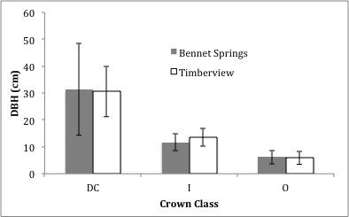

**Figure 3. Mean DBH (± 1 StDev) of trees in each crown class (Dominant and codominant (DC), intermediate (I) and overtopped (O)) at two sites in Virginia.** **The DC trees (the tallest trees in the forest) had the largest DBH. DC trees also had high standard deviations because there were some very large diameter trees in this category (e.g. 107 cm).**

**Ecological Succession in Forests**

Community species composition is constantly changing in forested ecosystems and is largely driven by the changes in tree species composition. This process of continual change is called ***ecological succession***. The understanding of ecological succession is a key element in restoring communities and ecosystems after natural or anthropogenic disturbances.

The historical view of ecological succession was that it was orderly and predictable (Cowles 1889, Clements 1936, Connell and Slatyer 1977, Odum 1969). According to this view, a predetermined sequence of communities would replace one another leading toward a final, self-replacing community called the climax. Studies of succession following glacial retreats, massive deposition of volcanic ash, or creation of new sand dunes all revealed a progression of species composition over time that followed consistent trends. These are examples of ***primary succession***, in which the communities assemble without any significant influence of prior communities.

Far more common is ***secondary succession***, community change following a lesser disturbance such as forest fire, hurricane damage, or tree diseases, as well as reversion of an agricultural area to forest. In these cases the prior community can have an important effect on the course of succession. There are a huge number of factors that can influence the course of secondary succession, many environmental (Gleason 1926), and the sequence of species composition change is not so easily predicted (Turner et al. 1998). Of current interest is how global climate change will potentially shift the geographic range of tree species due to changing environmental conditions, such as temperature and rainfall. For example, Johnstone and Chapin (2003) found the northward expansion of lodgepole pine (*Pinus contorta*) to not be in equilibrium with the current climate.

Examining the species composition of trees in different size classes (e.g., using DBH) can indicate whether a forest is undergoing shade tolerance succession. In secondary succession, ***early successional species*** are those whose seedlings grow fast in high light conditions and dominate early after a disturbance. When they become adults, their shade prevents their own seedlings to thrive, making them ***shade intolerant species***. ***Shade tolerant species***,seedlings that survive in lower light environments, become more abundant as they replace the early successional species, making them ***intermediate successional species***. In time, the most abundant large trees in a forest are the ***late successional species*** whose seedlings can tolerate the lowest light conditions. Therefore the shade tolerant model of succession would predict early successional species (e.g., pines, yellow-poplar, aspen) to be replaced by intermediate successional species (e.g., oaks, red maple, black cherry) to be replaced by late successional species (e.g., sugar maple, American beech, eastern hemlock; Appendix 1).

**II. Ecological Research as Education Network (EREN)**

Read about EREN on the web page: http://erenweb.org/project/rcn-project/

A. Start with the “About” tab and read

1. The Missions and Goals

2. Look around the rest of the web pages.

3. Find where the PFPP (Permanent Forest Plot Project) is described and read about it.

B. Take what you read and summarize what EREN and PFPP are about (in your words; don’t copy and paste). Answer in a well-developed paragraph and include in your answer what the acronym EREN stands for.

**III. Study Sites**

Carvins Cove Nature Reserve is a 4,500 ha of protected forest surrounding a 320 ha Reservoir in Roanoke County, VA ([http://www.roanokeoutside.com/carvinscov](http://www.roanokeoutside.com/carvinscove)e). There are four research plots at each of two research sites: Timberview and Bennett Springs. Timberview is an upland site on acidic soils (pH mean 4.5) whereas Bennett Springs is in a floodplain with seasonal standing water and higher pH (mean 6.5). Roanoke College students established the Timberview plots in 2011 and the Bennett Springs plots in 2012. The four plots at each site are about 20-60 m apart in the same forest type making them replicate plots for each site. Therefore, all the trees in an 800 m2 area was measured at each site (Timberview and Bennett Springs).

The Colby College Cross-Country Trails study site, in Waterville, Maine, consists of open field with tall grass and mostly wooded area with maple, birch, aspen and oak trees. The forest was logged and began regeneration in 1950. The study location falls within a humid temperate climate and receives an average of 910 cm of annual precipitation. The Colby College location has 5 separate study sites with six plots within each study site (3 with invasive species removed and 3 control) for a total of 30 plots - three control plots were used for this data exercise, for a total analysis area of 1200 m2. All plots are interior forest plots, lie under 100 m in elevation, and are in the Buxton Silt Loam soil order. Invasive species found within the plots include *Rhamnus cathartica, Rosa multiflora, Celastrus orbiculatus,* and *Lonicera morrowii*.

The Macalester College study site is located 27 km from St. Paul at the Katharine Ordway Natural History Study Area in Inver Grove Heights, MN. The 113 ha reserve is comprised of eastern broadleaf continental forest with an average of 634 cm of annual precipitation, and is situated along the Mississippi River. The Macalester College location has a total of 12 plots within this one study site - four plots were used for this data exercies, for a total analysis area of 1600 m2. All plots are interior forest plots, situated at approximately 230 m in elevation, and contain alfisol soils. Invasive species found within the plots include honeysuckle, buckthorn, and garlic mustard.

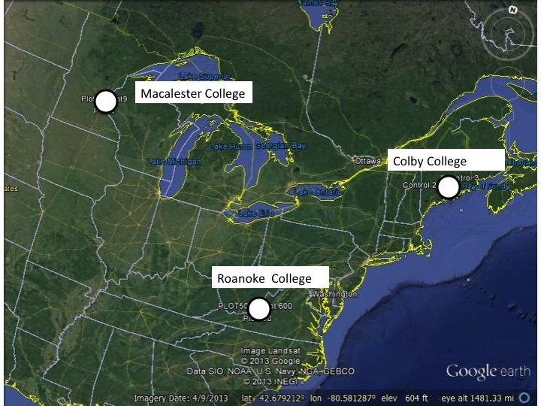

**Figure 4. Map of the study site locations.** (Google Maps)

**Developing Research Questions/ Hypotheses**

Using resources from class or group discussions, lectures, and readings, develop your research question or hypothesis below. To test your hypotheses, you will be provided datasets from four forests that include the species name, DBH and size class for each tree identified. Be sure to explain the ecology that led you to these questions or hypotheses. This information will be very helpful when you interpret your results.

**Data Analysis**

**I. Overview of Datasets**

The dataset file contains data on 801 different trees that were located in 15 different 400 m2 plots across the four study sites described above. The data columns from the PFPP datasets are: the institution where the data were collected, the site name, plot name, tree number, inventory status, stem type (single or multi-stemmed), species code (see Appendix A for full names and vertical layer), diameter in cm at breast height (DBH), and soundness. These data only include trees that were given the inventory status of *initial living*. Dead trees were excluded because dead trees will not contributing to the future species composition. The column of DBH class was added and the classes are as follows, small: 2.5-7.9 DBH, intermediate: 8-17.9 DBH, and large >18.0 DBH. Find a full description of data collection methods in the PFPP Protocol (Kuers et al. 2014). Each site is on a different worksheet in the Excel data file.

**II. Download Data**

1. Your instructor will tell you where to access the file **EREN Species Composition Data**.

2. Download it and save it under a different name that way if you end up downloading the data again, it will not overwrite the file you have been working on.

3. Open the file and notice that there are four worksheets; one for each site. Your instructor will tell you which or how many of the sites you will be working with.

4. Each worksheet has ten columns of data: institution where the data were collected; the site name where the plots were located; plot names for the 400m2 areas where the trees were measured; tree number - the number on the metal tag nailed to each tree; stem type - single stem or multi-stem; species code - see the species list in appendix 1; dbh - diameter of each tree in cm; soundness is a measure of how much rot is in a tree; DBH class as described above.

**III. Making a Species Composition Figure**

*You will use Pivot Tables to summarize the total number of trees by species and DBH class.*

1. Go to the worksheet for the first site for which you are making a species composition figure.

2. Select all of the data including the header row.

a. Make sure you have not selected any empty rows or columns

3. Go to the **Insert** tab along the top

4. Select **Pivot Tables** (it is all the way to the left under Insert)

5. Click **OK** (the pivot table will be entered into a new worksheet - be sure to label the new worksheet according to the site location you are working on)

6. Move

a. **DBH class** into the **Column Labels**,

b. **species code** into **Row Labels**

c. **species code** into **Ʃ Values**.

7. Make sure under **Ʃ Values** it says **Count of species code**.

*This pivot table has added up all the trees in each species by DBH class. Take the time to figure out what Excel is doing. That way you will learn how to use and apply pivot tables to other tasks. In this lab, we will not use Grand Totals because you cannot always tell what they are (sums, means, etc.)*

*The data in the pivot tables are hardwired back to the original data. You are now going to copy and paste the data using the following procedure to break that link so that you can manipulate the data.*

8. Select all the species names and the values for all the DBH classes.

a. Do not select any header or grand totals.

9. Copy

10. Highlight a cell in column A, a couple of rows down from your pivot table

11. Right click on that cell and choose **Paste Special…**

a. Select **Values**

b. Click **OK**

c. Write some notes in the margin here on what you did so you can remember for next time.

d. You may need to adjust the column widths so that you can see the data better.

*Next, you are going to move the data around and sort the data so that your species composition figure shows the LARGE DBH trees in the first and in descending abundance*.

12. In the cell above the first species, write the site name (e.g., Colby College) so you don’t forget.

13. In the row above the numbers you copied, type in the correct size class by looking at your original data (i.e., Intermediate, Large, Small)

14. Using the **Copy** and **Paste** functions, rearrange the columns so that they are in descending order (Large, Intermediate, Small)

15. Lastly, you will sort your data

a. To sort, select all your data and your header row.

b. Go **Data** in the menu bar at the top

c. Select **Sort** (be sure to check the box, my data has headers)

d. Sort by **LARGE** from **Largest to Smallest**

*Next you will make your figure.*

16. Select all of your data and your header row.

a. Go to **Insert** and select **Chart**

b. Choose the first **Column** figure

c. Work on formatting your figure so that it is similar to Figure 5.

17. Copy and paste it into a Word document (portrait), where you will add a great figure legend.

**IV. Additional Figures**

If you were assigned to make additional species composition figures return to step III 1.

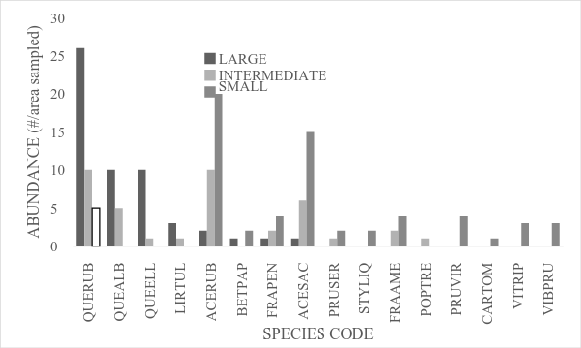

**Figure 5. Species Composition**……. Write a really good figure legend remember to use the correct units on your y axis label.

**V. Interpreting Species Composition Figures**

1. Before you interpret the data in your species composition figure, practice on figure 5.

a. What type of forest is this?

i. Typically the most abundant, large trees determine the forest type. Of the trees in the large diameter size class, which three species are the most abundant? Use the species list in Appendix 1 to help.

b. Are these species likely to persist as the most dominant large trees in the future?

i. To answer this question look to see how abundant the intermediate and small diameter trees of these species are compared to other species. Are there species with more intermediate and small diameter trees?

c. Is the species composition of this forest likely staying the same or changing? Does the pattern of change follow the predictions from the concepts of succession or failed oak regeneration or another concept you learned about?

d. Discuss your answers with other students and your instructor.

e. Now, use this approach to analyze the species composition in the figures you made to articulate the forest dynamics that may be operating.

**Literature Cited**

Clements, FE. 1936. Nature and structure of the climax. The Journal of Ecology 24:252-284.

Clements, FE, JE Weaver, and HC Hanson. 1929. Plant competition: An analysis of community functions. Carnegie Institution, Washington, D.C.

Connell, JH, and RO Slatyer. 1977. Mechanisms of succession in natural communities and their role in community stability and organization. The American Naturalist 111:1119-1144.

Cowles, HC. 1899. The ecological relations of the vegetation on the sand dunes of Lake Michigan. Botanical Gazette 27:95-117, 167-202, 281-308, 361-91.

Ellison, AM, et al. (20 authors total). 2005. Loss of foundation species: consequences for the structure and dynamics of forested ecosystems. Foundations in Ecology and the Environment. 3:479-486.

Gleason, HA. 1926. The individual concept of the plant association. Bulletin of the Torrey Botanical Club 53:7-26

Grime, JP. 1984. Dominant and subordinate components of plant communities: Implications for succession, stability and diversity. In: Gray AJ and MJ Crawley (eds.) Colonization, succession and stability. Blackwell, Oxford, UK.

Huston, MA. 1994. Biological diversity: The coexistence of species on changing landscapes. Cambridge University Press, Cambridge, UK.

Johnstone, JF and FS Chapin. 2003. Non-equilibrium succession dynamics indicate continued northern migration of lodgepole pine. Global Change Biology 9:1401–1409.

Kuers, K, E Lindquist, J Dosch, K Shea, J-L Machado, K LoGiudice, J Simmons, and .Anderson. 2014. Permanent Forest Plot Project Protocol <http://erenweb.org/>

Odum, EP. 1969. The strategy of ecosystem development. Science 164:262-270.

Turner, MG, VH Dale, and RH Gardner. 1989. Predicting across scales: Theory development and testing. Landscape Ecology 3:245-252.

Footnotes for Appendix 1.

*Indicates no native species  
^Canopy species mature and usually reproduce at codominant or dominant size. Midstory species mature and usually reproduce as an overtopped or intermediate size and rarely reach codominant size.  
# Shade tolerance of seedlings. Low is indicative of an early successional species; intermediate is indicative of intermediate successional stage, and high is indicative of late successional species.

**Appendix 1: Species List**

|  |  |  |  |  |
| --- | --- | --- | --- | --- |
| Species Code | Scientific name | common name | mature size^ | Shade tolerance# |
| ABIBAL | Abies balsamea | balsam fir | Canopy |  |
| ACENEG | Acer negundo | boxelder | Canopy |  |
| ACERUB | Acer rubrum | red maple | Canopy | Intermediate |
| ACESAC | Acer saccharum | sugar maple | Canopy | High |
| ALNINCR | Alnus incana subsp. rugosa | speckled alder | Canopy |  |
| AMEARB | Amelanchier arborea | downy serviceberry | Midstory |  |
| BETPAP | Betula papyrifera | paper birch | Canopy | Low |
| BETPOP | Betula populifolia | gray birch | Canopy | Low |
| CAROVA | Carya ovata | shagbark hickory | Canopy | Intermediate |
| CARSPP | Carya spp | hickory spp. | Canopy | Intermediate |
| CARTOM | Carya tomentosa | mockernut hickory | Canopy |  |
| CELOCC | Celtis occidentalis | hackberry | Canopy |  |
| CERCAN | Cercis canadensis | eastern redbud | Midstory |  |
| CORAMO | Cornus amomum | silky dogwood | Midstory |  |
| CORFLO | Cornus florida | flowering dogwood | Midstory |  |
| FAGGRA | Fagus grandifolia | American beech | Canopy | High |
| FRAAME | Fraxinus americana | white ash | Canopy | Intermediate |
| FRANIG | Fraxinus nigra | black ash | Canopy | Intermediate |
| FRAPEN | Fraxinus pennsylvanica | green ash | Canopy | Intermediate |
| HAMVIR | Hamamelis virginiana | witch-hazel | Midstory |  |
| LIRTUL | Liriodendron tulipifera | yellow-poplar | Canopy | Low |
| MAGACU | Magnolia acuminata | cucumber magnolia | Canopy |  |
| MALSPP | Malus spp | crabapple species | Midstory |  |
| NYSSYL | Nyssa sylvatica | black tupelo | Midstory |  |
| OSTVIR | Ostrya virginiana | eastern hophornbeam | Midstory |  |
| OXYARB | Oxydendrum arboreum | sourwood | Canopy |  |
| PINECH | Pinus echinata | shortleaf pine | Canopy | Low |
| PINSTR | Pinus strobus | eastern white pine | Canopy | Low |
| PINVIR | Pinus virginiana | Virginia pine | Canopy | Low |
| PLAOCC | Platanus occidentalis | sycamore | Canopy |  |
| POPGRA | Populus grandidentata | bigtooth aspen | Canopy | Low |
| POPTRE | Populus tremuloides | quaking aspen | Canopy | Low |
| PRUAVI | Prunus avium | sweet cherry | Canopy |  |
| PRUSER | Prunus serotina | black cherry | Canopy | Intermediate |
| PRUVIR | Prunus virginiana | chokecherry | Canopy |  |
| QUEALB | Quercus alba | white oak | Canopy | Intermediate |
| QUEELL | Quercus ellipsoidalis | northern pin oak | Canopy | Intermediate |
| QUEMAC | Quercus macrocarpa | bur oak | Canopy | Intermediate |
| QUEMON | Quercus montana | chestnut oak | Canopy | Intermediate |
| QUERUB | Quercus rubra | northern red oak | Canopy | Intermediate |
| QUEVEL | Quercus velutina | black oak | Canopy | Intermediate |
| RHACAT | Rhamnus cathartica | common buckthorn* | Midstory |  |
| TSUCAN | Tsuga canadensis | eastern hemlock | Canopy | High |
| ULMAME | Ulmus americana | American elm | Canopy | Intermediate |
| UNKSPP | Unknown species | Unknown species | Canopy |  |
| VIBPRU | Viburnun prunifolium | blackhaw | Midstory |  |
| VITRIP | Vitis riparia | Riverbank grape | Canopy |  |
| VITSPP | Vitis spp | grape vine | Canopy |  |
| ZANAME | Zanthoxylum americanum | Prickly ash | Canopy |  |